

Desautels Faculty of Management

BUSA 664 - Creating the Small Enterprise

American University of Technology
Qatar
Business Plan

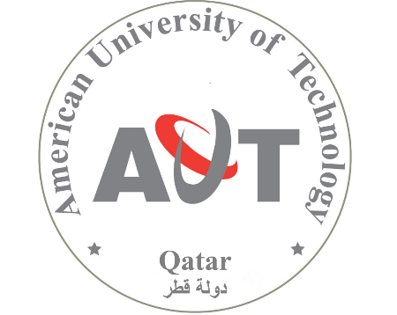

Submitted By:
Nicole Dunbar (ID#260406065)
Elie Hinain (ID#260578637)
Roman Ivanov (ID# 260455614)
Hwara Kim (ID#)
Gowri Mangala (ID#260511307)
Nan Wang (ID#260577139)

Presented To:
Professor Alex Kalil

Wednesday, December 3, 2014
Table of Contents

1. Executive Summary 2

Context and Company 2

2.3 American University of Technology History 2

2.4 Idea Generation 2

2.5 Mission and Vision 2

2.2 Alignment with Qatar National Vision 2030 (QNV 2030) 2

2.6 Existing Customers and Partners 2

3. Market 2

3.1 Pain in the Market 2

3.2 Our Solution 2

3.3 Market Environment 2

3.4 Drivers, Trends & Challenges 2

4. Competition 2

4.1 Competitors Types and Quadrant 2

4.2 Direct Competition 2

4.3 Indirect Competition 2

4.5 Competitive Advantages 2

5. Products and Services 2

5.1 Distinguishing Features 2

5.2 The Development 2

5.3 Key Program Branches 2

5.4 Innovations: In Detail 2

5.5 Access: In Detail 2

5.6 Undergraduate: In Detail 2

5.7 Specializations: In Detail 2

5.8 Research: In Detail 2

5.9 SERVICES 2

5.10 The Evolution: Life Cycle 2

5.11 Application: Phase I, II, III & Beyond 2

5.12 Quality Assurance 2

5.13 Intellectual Property 3

6. Sales and Marketing 3

6.1 Marketing Strategies 3

6.2 Associations 3

6.3 Channels 3

6.4 Sales Strategies 3

6.5 Pricing 3

6.6 Business case, ROI 3

7. SWOT Analysis 3

8. Operations 3

8.1 Location 3

8.2 Facilities 3

8.3 Organizational Structure 3

8.4 Key Operational Offices 3

8.5 Personnel Plan 3

9. Finance 3

9.1 Financial Strategy 3

9.2 Funding Requirements 3

9.3 Financial Forecast 3

Executive Summary

Context and Company

2.3 American University of Technology History
AUT was founded in 1998 in Lebanon and received official decree as an accredited university in the year 2000. At the time, AUT began with 150 students and consisted of three faculties: Faculty of Applied Sciences, Faculty of Arts and Humanities, and Faculty of Business Administration. AUT’s main campus is located in the city of Halat. In 2005, AUT established a second campus in the second most populated city in the north of Lebanon, Tripoli. In 2010, a third campus was established in the city of Sour, in the southern part of Lebanon. Today AUT has over 3,000 students in all campuses, and the number of enrollments increase every year.

2.4 Idea Generation
Political instability of the region has been crippling Lebanon’s economy for decades. Students have a hard time paying tuition and jobs are few and far between. In response, early in 2014 AUT has begun looking into the possibility of global expansion. Fortuitously, an investor approached AUT later that year with the offer to establish a campus in the City of Doha in Qatar. The American University of Technology – Qatar (AUT-Q) is a branch campus of AUT in Qatar. Much like its parent institution, AUT-Q will adopt an American post-secondary educational system while maintaining a Middle-Eastern culture. Convergence of Western type education with distinctive local culture is in tune with the principles of Qatar’s own national vision.

2.5 Mission and Vision
AUT-Q’s mission is to aid Qatar to become a dynamic educational hub to graduate professionals who drive the future of Qatar. AUT-Q’s vision is to provide an innovative, technology-rich, entrepreneurial, experiential university that produces socially active and market-ready graduates.

2.2 Alignment with Qatar National Vision 2030 (QNV 2030)
Education and environmental sustainability are two primary aims outlined in the Qatar National Vision (QNV 2030). AUT-Q integrates Qatar’s goal of long-term environmental sustainability through the content and focus of its educational programming and initiatives.
A driving initiative is the country’s articulated shift from an oil-based economy to an internationally influencial knowledge economy. The vision specifically emphasizes Qatarization - the need to increase the role of Qataris in all sectors of their country’s economy and to promote a traditional values in a modern context. It describes an accessible, world-class educational system that responds to current and future needs of the labor market, fosters innnovation, and develops a motivated Qatari workforce of entrepreneurs, artists, and professionals.

2.6 Legal Status
AUT-Q is an independent, non-profit organization that will be organized under the laws of the State of Qatar and will be funded by fees and charges, donations, and direct subsidy from of the State of Qatar. The scope of AUT-Q’s activities will be governed by the terms of a comprehensive agreement between AUT and the State of Qatar.

2.6 Existing Customers and Partners
Existing customers include current students enrolled at AUT who may wish to transfer to Qatar and continue their education at AUT-Q. The university’s main customers, however, are prospective Qatari students wishing to pursue post-secondary education and remedial programs, professionals in the industry wishing to obtain certifications and professional training, and housewives who wish to integrate into the workforce.

AUT’s current partner institutions will be given priority over other institutions to engage in a new partnership with AUT-Q. These partners include:
- Université de Toulouse: A Master program in Economics of International Tourism is offered jointly by both universities.
- The University of London: AUT offers support to students enrolled with University of London in the Master of Laws- LLM program.
- The University of Dayton, Ohio: Students may complete their Engineering Bachelor program with the University of Dayton.
- Davenport University, Michigan, USA: AUT and Davenport University offer learners a unique opportunity for graduate studies in Business Administration with concentrations in Strategic Management and Health Care Management.
- The Center for Maritime Economics and Logistics: A cooperation agreement ensures the teaching of specialization courses in the areas of shipping, transport and logistics by top faculty from MEL to AUT students majoring in Transport management and Logistics.
- Empire State College of State University of New York: An academic affiliation agreement allows students at AUT to complete bachelor programs with SUNY Empire State College without the need to travel to the US.
- Oklahoma University: An agreement on educational cooperation allows the exchange of students and faculty, joint research and publications.
- Istituto Europeo di Design, Milan, Italy: Students in design programs may internship at Milan’s top fashion and luxury products firms.
- The Lebanese University: An exchange agreement that covers Bachelor, Master and PhD programs for faculty, students and joint projects and research.
- CMA-CGM is the third largest shipping company in the world and accepts AUT interns majoring in Transport Management.
- The Tannourine Water Company is the sponsor of the Water Resources Science program at AUT.
- The Ministry of Energy and Water accepts AUT trainees majoring in Water Resources Science.
- The Ministry of Environment accepts AUT trainees majoring in Environmental Health.
- The Ministry of Tourism is one of the three parties (with AUT and Université de Toulouse) that manage the Executive Program in Tourism Management.
- AUT is a CISCO Academy and provides training and testing leading to certification from CISCO in all network specializations (AUTCE).
- AUT is an IT Academy for Microsoft offering courses and testing leading to certification from Microsoft (AUTCE).

3. Market

3.1 Pain in the Market

Driven by QNV 2030, a host of new and exciting industries are opening in the private sector. These industries include the maritime industry, renewable energy sector, IT and communications sector and the health care industry. These industries call for a large number of well trained and qualified professionals to convert the vision to reality. However, the Qatari youth still prefer to go to the government sector due to the perceived prestige in holding a government position and the various benefits that it entails.

Thus, there is a severe shortage of Qataris in these fields to drive the economy. Our market analysis reveals that Qataris in general lack the necessary skills for these jobs. Specifically, Qataris lack academic skills (in-depth knowledge about subjects), technological skills (familiarity with computers and other latest technology), soft skills (communication ability) and general skills (work etiquette, passion for a job etc.)

3.2 Our Solution

AUT-Q addresses this market pain of a lack of skill-based education among Qataris. By providing a career focused and specialised approach, we move away from the theoretical and academic framework of education. Instead, we offer a more practical and hands-down approach to education reflecting the motto “Learn by Doing.”

3.3 Market Environment

- Geographic: Qatar is located in Western Asia, occupies the Qatar Peninsula on the northeastern coast of the Arabian Peninsula in Western Asia. The Persian Gulf borders the territory with Saudi Arabia neighboring the south perimeter.

- Demographic: In 2013, Qatar's total population was 1.8 million, 20% of which are Qatari citizens. The majority in the population are male expatriates. Men comprise 70% of the total population.

- Cultural: Qatar is an Arab and Islamic country. It is a hybrid of traditional and modern culture. Family values remain a central cultural pillar. In Qatari society, gender roles are relatively distinct. Students and parents generally prefer an all-female or all-male education environment due to culture, religion, and course preferences. Even though co-education is increasing, there is no clear trend indicating if gender segregated or non-segregated learning environments are more popular. After graduation, Qatari women tend to take government jobs, particularly in education, health, and social affairs. High-level positions are held predominantly by men. Men engage in the public sphere more frequently than women.

- Political: Qatar gained full independence in 1971. Since June 1995, the country has been ruled by the Emir His Highness Sheikh Hamad bin Khalifa Al-Thani. The current leader in Qatar is Qatar's Sheikh Tamim Bin Hamad Al Thani.

- Economic: Qatar is one of the most prosperous countries in the world and has the fastest growing economy in the Gulf Cooperation Council (the GCC). Much of the economy’s growth has been driven by an expansion in the production of oil, liquefied natural gas and condensates. In recent years, Qatar strives to diversify and modernise the economy through increased spending on infrastructure, social programs, health care and education. Qatar’s booming economy, largely driven by gas revenues, has almost doubled over the past four years. The non-oil sector is also showing steady growth, which should come as relief to the government as it has long been pushing a more diversified economy. By last year-end, the economy grew to QR 700.3 bn (USD 192.39 bn) from QR 356 bn (USD 97.8 bn) as late as 2009.

- Legal: Qatari courts determine civil and commercial disputes in accordance with Qatari legislation. If no legislation is available with respect to a particular matter, Qatari civil and commercial courts will look to Shari’ah law and established commercial practices. After Saudi Arabia, Qatar is the most conservative society in the GCC as most Qataris adhere to the strict Wahhabi interpretation of Islam. Sharia law is the main source of Qatari legislation according to Qatar's Constitution.

3.5 Trends

The major trend affecting Qatari market of post-secondary education is the commitment of the Qatari government to turning their country into an international leader in education and research.

3.6 Drivers

The drivers behind this trend are:
- Climate change, which spurs a movement towards renewable energy and clean technology, thus creating demand for specialists in the relevant fields.
- Qatar’s spectacular economic performance in the past two decades, which allows the country to spend around USD 60 billion on education.
- The government’s understanding of the pressing need to replace the carbon hydro-based economy with a knowledge-based economy characterized by a more diverse economic landscape and booming private sector.
- Implementation of policies that incentivize Qataris to obtain qualifications needed to work in the growing private sector in order to develop and sustain the Qatari economy.
- A growing population that presently consists of an expatriate majority of 80% occupying both high and low-skilled employment positions in Qatar.
- The government’s shifting immigration policies to limit the number of expatriates in the workforce.
- Improving social status of women who are expected to play increasingly more important roles in the Qatari workforce.
- Mass communication technologies that increase the visibility and dominance of Western culture and the English language.

3.7 Challenges

Among AUT-Q’s major challenges are:
- Qataris’ general complacency with government positions that do not require post-secondary education and their lack of motivation to work in the private sector.
- Lack of coherent government policy to change the status quo in the public sector.
- Although gradually eroding, traditional expectations are still major barriers to attracting more women into colleges and the workforce.
- High school students are not adequately prepared for post-secondary education.
- Significant government funding available for post-secondary programming provides incentive for competition.

3.3 Market Size

Based on the data published by the Qatar Ministry of Development, Planning and Statistics, the total number of middle and high school students in public and private education in the academic year 2010-11 made up 72,754, of which about 15,000 graduate from high school annually. In addition, there are about 400,000 of Qatari adults between the ages of 18-49 who might be interested in continuing education, remedial, and career related coursework.

3.4 Customer Base

Our market analysis points to the following gaps in post-secondary offerings in Qatar:
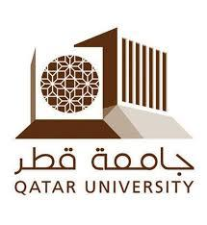
- Limited opportunities for students who need remedial academic course work before they can be admitted to a university. These students include high school graduates as well as older adults who decide to pursue a post-secondary education.
- Limited choices for high-achieving students in Qatar, especially women, who want to pursue high-quality four-year degrees other than those currently offered in Education City.
- Lack of degrees in career-related fields in Qatar. Degrees in such fields as engineering, business, and computer science would provide skills valuable to the labour market.

Our primary customer base largely corresponds to these underserviced groups of Qatari population and includes:
- High-achieving students who do not fall into the top ten percent who receive scholarships to study abroad or enter the Education City.
- Remedial students who wish to join a prep-course as a stepping stone to university.
- Entrepreneurs who wish to have a formal training in management.
- Professionals who seek extra qualifications or a competitive edge.
- Housewives who want to improve their knowledge and skills and obtain degrees, diplomas or certifications.

Among this target custormer base, our niche market is students who:
- Are career-oriented
- Desire english competency
- Prefer traditional values
- Look for high-quality and affordable service
- Require flexible academic schedules to manage family responsibilities
- Prefer remedial programs in a university environment

4. Competition

4.1 Competitors Types and Quadrant

According to our market analysis, AUT-Q’s major direct competitors are the currently existing post-secondary institutions in Qatar.

4.2 Direct Competition


Our major competitors are the already established and steadily growing colleges in Qatar that attract a fairly large segment of the local Qatari students. These colleges are appealing to the Qataris since they provide their courses within a traditional context. They still maintain some degree of gender segregation with separate classrooms for males and females. Also, courses in these colleges tend to be a bit easier to attract locals who are not high achievers.

Major players in this area include Qatar University, College of North Atlantic-Qatar and the Community College-Qatar. Taken together, they cater to almost 80% of the eligible Qatari students. Even though we share a general target market, our innovative and experiential approach sets us apart from these institutions that use a more theoretical and traditional approach to education.

4.3 Indirect Competition

Education City is a sprawling campus on the outskirts of Doha home to several colleges of international acclaim. Some of the prestigious ones include Carnegie Mellon University-Qatar, Texas A&M University-Qatar, Weill Cornell Medical College-Qatar etc. As premier institutes, they admit only high achieving and top students in Qatar. Education city is home to around 8% of the eligible Qatari students.

There is a growing trend among Qataris to pursue their higher education outside Qatar. The government heavily supports Qataris who get accepted to colleges abroad by providing them with extensive scholarships. Around 1,000 students leave Qatar per year to study abroad. Our analysis reveals that this trend is likely to continue and increase thus posing a threat to us by reducing the market size.

There is a segment among the Qataris who do not opt for higher education due to family responsibilities. This largely involves women who make up a significant percentage of the population. Others are some men who are the family’s primary source of income and so do not have the time to pursue education. Some Qataris are simply not interested in higher education since it is not an essential factor for them to get a decent government job.

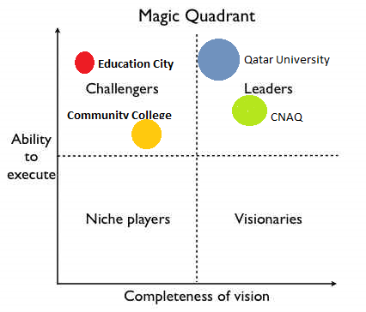

4.5 Competitive Advantages

(a) Existing Experience in AUT
AUT’s expertise and proven track record enables AUT-Q to gain a significant head-start. The fact that AUT-Q’s parent campus is in English and follows a curriculum that is more workplace focussed gives us a significant advantage over our competitors. At the same time, we will be able to preserve the traditional values and practices that will appeal the Qataris. This fusion of traditional and modern gives us a competitive edge over other universities.

(b) In Tune with the Qatar National Vision
Our University strategically positions itself in line with QNV 2030 helping Qataris to drive the development of their nation. Positioning ourselves here also attracts government policy makers thus paving the way for extensive government funding and support.

(c) Hands-on Experience
AUT-Q aims to be practical and hands-on university. Our guiding philosophy is “Learn by Doing”. Accordingly, our students are exposed to real world practices and scenarios that will equip them with practical and necessary career related kills.

(d) Dynamic
AUT-Q a dynamic institution that adapts and changes according to the Qatari pulse. We proactively explore untapped opportunities for training and education of Qataris supporting them, to better serve the country’s vision and at the same time fulfil the demands of the labour market.

Products and Services

5.1 Distinguishing Features

AUT-Q’s products and services directly are animated by QNV 2030’s aim of human development through education and environmental sustainability.

Its distinguishing features are:
- Our Focus: Career-driven training that fill industry and knowledge gaps in Qatar and prioritize environmental sustainability
- Our Practical Approach: Experiential-Academic learning
- Our Dynamic Culture: Bilingual & Traditional-Modern values
- Our Connections: Active Industry Relationships through inter-disciplinary programming, mentorship and fieldwork opportunities

5.2 The Development
AUT-Q’s development spans three main phases.

Phase I is key to establishing the university in the market as offering highly-specialized, dynamic and industry-relevant programming.

Phase II essentially doubles the programming to flesh out the university as a whole. This phase appeals to specific components of our niche market such as education professionals seeking a competitive edge.

Phase III is more conservative in size to ensure high quality programming.
PRE-OPENING : Initial Preparation
Team Recruitment  Investment Partners  Brand development  Online platform  Advertising  Market outreach |  | Staff Recruitment  Administration  Facility rental & preparation  Service partner recruitment  Insurance
PHASE I  Setting the Stage | PHASE II  Building Momentum |  | PHASE III  Taking Root
INNOVATIONS
Staff Mentorship Program  Eco-Innovate Project | Educational Coordination Program  Green Alliance for Innovative Action |  | ... ongoing ...
ACCESS
Enter & Excel : Academic Upgrades : Remedial course work  Your future is Qatar’s future : High School Outreach Program | Access Technology Courses  Conversational English Courses |  | ... ongoing ...
UNDERGRADUATE
Qatar Business Academy : Business Degree  Qatar Engineering Academy : Alternative Energy Engineering Major | Nursing & Health Sciences  Liberal Arts Academy |  | Applied Sciences Academy  Fine Arts Institute
SPECIALIZATIONS
Entrepreneurship Diploma (or Major)  Maritime Engineering Specialization  Renewable Energy Certificate | Applied Technology in Education : Graduate Specialization  Environmental Innovation : Graduate Specialization |  | Eco-Tourism : Liberal Arts Academy  Master in Laws : Master of Business Administration
RESEARCH
Qatar Pulse-Response Research Institute | Environmental Innovation Research Institute  Men & Education: Research PRoject |  | Inter-disciplinary Innovation Institute
SERVICES
LANGUAGE
Arabic | Arabic / English alternating course sections (selected programs) |  | Arabic / English alternating course sections (majority of programming)
SPACE
Classrooms : Offices :  Cafeteria : Lounge : Reading Area : Atrium  Religious Space : Parking | Greenery / Park |  | Adapted Vertical Farm (support on-campus food services)
CAREER
Professional-Student Mentor Program  Career Advisors  Internship & Co-ops Centre | The Professional : Seminar & Workshop Series |  | Alumni Association
STUDENT
Quality Assurance Centre  Childcare Services  Helpdesk  Academic Advising  eLibrary  Tutoring Support | English Language Tutors  eClass Seminars (for in-the-field courses)  Accessibility Office |  | ... ongoing ...
WELL-BEING
Mental Health Centre : Counselling Service  Financial Aid  Recreation Centre (Facility Partner)  Clubs | Healthcare Team  Soccer team |  | Sports

5.3 Key Program Branches

Five key branches encompass AUT-Q’s programming:

- Innovations: The Innovations branch entails programs aimed at the University’s operations and reaches its internal employees and external partners and potential collaborators. The objective is to respond to Qatari educational gaps through its back-end operational infrastructure and organization as a whole in harmony with its front-end academic programming.

- Access: The Access branch responds specifically to students who may benefit from outreach and remedial programs to motivate and improve academic readiness for post-secondary education. A major feature is its integration with the University-at-large with its unique student supports including Career Advisors, Mentorship, and Internship opportunities.

- Undergraduate: The Undergraduate branch responds primarily to Qatar’s general lack of Qatari professionals equipped in specific areas relating to industry demands. Its primary market are individuals seeking a career-oriented academic degree. This market reaches both academic savvy high school graduates and current post-secondary students seeking to transfer to a more career-based program (ie: from Qatar University).

- Specializations: The Specializations branch caters specifically to current professionals and graduate students seeking a competitive edge in a field specifically identified in Qatar’s National Vision. It offers both advanced degrees and certificate or diploma programs to target this market.

- Research: The Research branch applies an inter-disciplinary approach to ensure AUT-Q is aligned with Qatar’s ongoing shift towards a knowledge economy. It simultaneously provides advanced training and experience to current professionals as well as undergraduate and graduate students. Its activities also strengthen ties with regional and international industry stakeholders.

5.4 Innovations: In Detail

PHASE I
Eco-Innovate Project
This is a cornerstone program at the University as it actively connects students across disciplines with researchers and industry partners to develop and implement effective, innovative and sustainable solutions to current, local environmental challenges. The project models an inter-disciplinary internship and is mandatory to graduate from any access, undergraduate, or specialization program.

Staff Mentorship Program
Where possible, positions are full-filled by qualified Qataris. Those engaged by expatriates or foreigners reflect a mentorship framework whereby the individual works alongside the most qualified Qatari candidate in a mentorship capacity. This program uniquely provides advanced hands-on training to current Qatari professionals to respond to the lack of Qatari professionals (particularly women) in leadership capacities.

PHASE II
Green Alliance for Innovative Action
Inspired from Stanford University, this initiative seeks to collaborate across the University’s affiliates and partners to encourage and collaborate towards both short and long-term operations that align with global environmental sustainability aims.

Educational Coordination Program
A small team dedicated to program coordination and communications between education centres, funders, and employers. Special attention is paid to ensuring ongoing communications with labor market stakeholders to maintain responsivity in programming to meet market demands.

5.5 Access: In Detail

PHASE I
Enter & Excel: Academic Upgrades: Remedial course work
Our remedial program caters specifically to adults seeking post-secondary education and training in the University environment. It features an open admission policy, credit transfer with Qatar University (and selected Educational City institutions) and a flexible schedule to accommodate off-campus commitments.

Your future is Qatar’s future: High School Outreach Program
This dynamic summer high school outreach program engages students with a diverse range of professionals from innovative entrepreneurial companies founded by expatriates to established and thriving Qatari-run businesses.

PHASE II
Access English
Our English-learning programs are highly practical in that they emphasize conversational skills and are industry-specific.

Access Technology
This program is key to students’ acquiring basic competencies in current and new technologies and software.

5.6 Undergraduate: In Detail

PHASE I
Qatar Business Academy: Business Degree
The Academy offers practical, experiential learning programming that makes direct links between theoretical coursework and practice in the field. Standard courses such as accounting and management feature project-based assignments that support local companies and organizations. Further, co-operatives and internships provide the centrepiece for degree programs.

Qatar Engineering Academy: Alternative Energy Engineering Major
Modeled after a program at Carleton University, this degree blends analytical and hands-on skills development to enhance and design sustainable energy systems using renewable energy technologies.

PHASE II
Nursing & Health Sciences
The Nursing program features a coursework-internship model where students take core courses alongside field placements in various healthcare settings. Specialized certificates including healthcare technicians, applied psychology are also offered

Liberal Arts Academy
This Academy provides students with the opportunity to engage in Education City programming within a Qatari-centred environment. Fine arts, interdisciplinary studies, history, media are a sample of courses available.

PHASE III
Applied Sciences Academy
This Academy offers an experiential framework that combines course-based material in applied science and technology with practice-based internships. The Academy compliments the developments already established through its Engineering and Environmental programming.

Fine Arts Institute
This Institute is the first of its kind in a University setting in Qatar. The stand alone department caters to Qatari students looking to specialize specifically in the fine arts and pursue professional careers in artistic expression.

5.7 Specializations: In Detail

PHASE I
Qatar Business Academy: Entrepreneurship Diploma* (or Major)
The diploma offers the first of its kind in the country. It features a highly-practical focus on developing leadership, market and project management and technical operational skills. The specialization welcomes a diversity of students including high school and post secondary graduates, current and prospective business owners.

A major component is the continued supports available to diploma graduates including an active mentorship program and ongoing links with business students to further strengthen entrepreneurial initiatives.

* NOTE: Recent government launch of Enterprise Qatar to support entrepreneurs.

Marine Engineering
This specialization responds to the rapidly growth of marine and coastal engineering in the Gulf region and Qatar’s recent multi-billion investment into a new mega-port project. The curricula focuses on new technologies and environmental sustainability.

PHASE II
Environmental Innovation: Graduate Specialization
This specialization caters to graduates and professionals looking to gain competency in the intersection between industry and natural resource development with environmental policy and economics.

Applied Technology in Education: Graduate Specialization
This program offers education graduates and professional educators the unique opportunity to specialize in newly developed, innovative pedagogical methods thereby gaining a critical competitive edge in the labor market.

PHASE III
Eco-Tourism: Liberal Arts Academy
This specialization uses an academic-cooperative education blend designed to offer students the building blocks to build environmentally sustainable tourism and infrastructure in Qatar.

Master in Laws: Master of Business Administration
Unique to the University, this joint program offers highly specialized legal and business education. It features course programming that facilitates learning at the intersection of law and business in the Qatari-context.

5.8 Research: In Detail
PHASE I
Attending to Industry / Academia Gaps
Qatar Pulse-Response Research Institute
A small team of engaged students and specially recruited researchers conduct research on current and future trends in Qatar focusing on current workforce strengths and areas for development among the Qatari population. Its mission is to actively inform the University’s planning and programming with a mind to effectively respond to current gaps as well as pioneer and develop untapped opportunities (i.e: hydrocarbon technologies).

PHASE II
Attending to Environmental Aims
Environmental Innovation Research Institute
An inter-displinary team of students, graduates, researchers, and businesses engage in research projects that respond to specific environmental management needs in Qatar to research and develop innovative and effective approaches to address environmental concerns.

Attending to the Gender Imbalance
Men & Education: Research Program
This research initiative is dedicated to understanding the disproportionate gender engagement in post-secondary education and formulating effective strategies to address the imbalance.

PHASE III
Inter-disciplinary Innovation Institute
The Institute brings together student and industry leaders in each of the University’s to apply their expertise to the research and development of projects that directly activate the Qatar National Vision 2030. This includes education and enivronmental innovations. Its activities compliment the Qatar Pulse-Response Research Institute.

5.9 SERVICES
Space
Building Facilities & Recreation Services
University facilities in its initial five year development largely consist of building rentals and partnership arrangements with nearby organizations to accommodate otherwise unavailable facilities (i.e. fitness and recreation centre).

Green Infrastructure
In the University’s securing of space and partners, priority is given to those that feature sustainable energy efficient infrastructures and environmentally responsible practices. During this development period, significant research and planning is directed at building the University’s future campus as a leader in environmentally conscious infrastructure in Qatar.

Gender Segregation
In response to the public and private demand, AUT-Q provides gender segregated learning environments. This may move toward a blended gender structure upon student demand.

Language
The University’s aims toward a dynamic bilingual learning environment. Arabic serves as the founding language and English is increasingly offered on a rotational basis. Tutoring services are offered to complement its practically-oriented language courses.

Career
These services are geared towards cultivating a professional framework among students. Distinct features include its Professional-Student Mentor Program, The Professional - Seminar & Workshop Series, and a centre dedicated to connecting and supporting students engaged in internships and co-ops.

Student
Student services feature flexible course schedules that accommodate part-time programs and respond to the demand for evening classes for students with family responsibilities. Childcare services are additionally offered ensure students’ access. Student services also include academic supports such as tutoring and academic skills improvement workshops.

Well-Being
Consistent with the National Vision, the University emphasizes the need for both physical and mental well-being among its students offering services that include counselling and recreation opportunities.

5.10 The Evolution: Life Cycle

General Overview
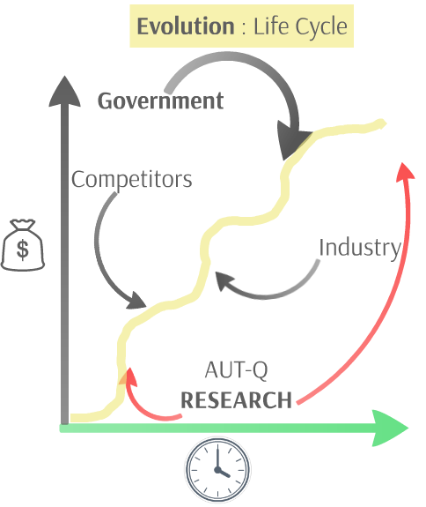
The evolution of the University is proactive and adaptable. It necessitates a Qatari-focused and Qatari-driven approach in both the development and delivery of the University programs. As such, the establishment of mentorship, research, and partnership programs that actively integrate government and industry stakeholders with the University’s community ensure its growth is an extension of the demands and aspirations of Qatari knowledge landscape.

Specific Life Cycle
The specific life cycle of the various products and services offered follow a s-shaped curve. The addition and refinement of new academic programs will support an influx of new students and partners. This settles into a mature phase as our competitors respond to our product.

The illustration highlights the major influence of government support, competitor response, industry demands that create the ebb and flow of the product’s development over the three phase period. Importantly, the University’s research findings influence decisions to change or introduce programs and services throughout the course of the university.

Overall, once all major access, academic, research, and innovative branches and facilities are well-established the ebb and flow of each particular product and service will shift in response to student demands, product competition, and the larger Qatari professional and workplace market. For instance, an earlier accounting course that more closely models a traditional approach will be phased out with a field accounting course that takes place through off-campus mentorship with a company.

One significant future factor concerns the future development of the University’s own campus. Depending on the scope and speed of this development, the University may experience a marked decline in its development as resources are channeled to effect the transition. A sharp increase is likely after the new campus is open given the expected influx of students and partners attracted to the new facilities. This consideration largely influences the evolution after the 3 phases outlined in this plan.

5.11 Application: Phase I, II, III & Beyond

Initial Introduction: Phases I through III comprise the initial introduction of the University’s products and services application as its core programming is introduced throughout the five year period. The initial year of each phase denotes a sharp incline of students given the new programming. The subsequent year is expected to show a more moderate enrolment increase.

Growth stage: The growth stage reflects the end of Phase III as attending students approach 2,000 and the University transitions to its own campus (assuming it rents facilities first). It is a shorter period of considerable growth as its new facilities attract a greater portion of the University’s target market. It also involves significant response to emerging programs offered by competitors and to its ongoing research findings.

Mature stage: Once the University is clearly established as distinct within the Qatari landscape and known for its experiential and innovative approach - and competitors have positioned themselves accordingly - the mature stage is entered. The ebb and flow of specific specializations and programs continues as informed by its own research and industry demands. It is projected this stage will last at least two decades.

Gradual decline: The far-off future of the University’s programming is greatly speculative. The government’s comprehensive and radical shift from an oil to a knowledge-based economy suggests that educational institutions will be a fundamental pillar in Doha for several decades to come.

5.12 Quality Assurance

The University’s innovative focus necessitates active quality assurance activities. These activities are housed in the Quality Assurance Centre which facilitates mid and end of term course evaluations, program review committees, and Innovation and Excellence awards for both teacher and student achievements. It also conducts research on effective creative pedagogies and facilitates ongoing professional development workshops to its administration and faculty.

5.13 Intellectual Property

The University’s brand as innovative and experiential is essential to the successful establishment of the product on the market (both short and long term). As significant weight is given to educational development in the country, there is potential for other ventures to conduct similar operations using our image. Therefore, proper steps will be taken to ensure trademark protection of the University’s image under Qatar intellectual property law. Further, the University’s intellectual property strategy will extend progressively to ensure the protection of literature and initiatives developed out of its research institutes.

6. Sales and Marketing

6. Sales and Marketing

6.1 Marketing Strategies

(a) Objectives
- To enroll 500 students in Year 1, 950 students in Year 2, 1755 students in Year 3
- To build reputation and image of AUT-Q
- To disseminate information through appropriate channels of distribution
- To develop effective sales tools

(b) Branding
AUT-Q adopts the established branding AUT to capitalize on the quality and credibility already garnered abroad.
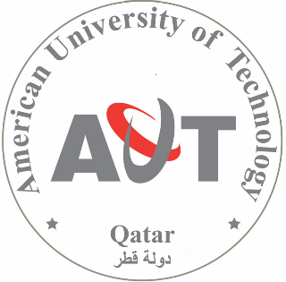

(c) Brand Personality
Excellent
World class programs, faculty, and research
Dynamic
Vibrant
Fast-moving
Stimulating
Diverse
Kaleidoscop of people and learning opportunities
Modern
Innovative
Forward-looking
Traditional
Rooted in Qatari values and culture

(c) Advertising
To interact with its target customers, we plan to advertise AUT-Q through a variety of outlets: TV, radio, local press, Internet, posters, flyers, and billboards.

(d) Website
- Engaging website design
- Accessible information
- Transactional features (e.g. students may pay fees online)

(e) Social media
AUT-Q will establish and maintain active online and social media presence. This includes:
- Facebook, Twitter, YouTube, Wikipedia, Instagram, Google+, LinkedIn etc.
- Online shared links with local partners and associations

(f) Programs and Events
Promotional events will include:
- Open house for students and industry partners
- Parents’ day for parents and bring a friend day
- Green project: Promoting solar technology and effective use of water resources in urban environments.
- Promotional training for professionals (i.e. Building Entrepreneurial Character)
- Special programs to increase student engagement and motivation (e.g. Emerging Technologies for Educational change - part of incentivizing students to engage in post-secondary education and enhancing technology competences)

(g) Public relations
Coordination across multiple organizations is crucial and includes Supreme Education Council, Qatar Foundation, Higher Education Institute, CAN-Q University and Qatar University. This is largely facilitated through our Educational Coordination Program (See Innovations: In Detail).

We will also create, maintain and enhance strong long-term relationships with high school principals, teachers, students, and parents by providing summer remedial programs, teacher training, youth workshops and special workshops for housewives.

We will invite guest speakers from private companies and industries and also be part of important conference and major seminar to build relationships with the public. Most importantly, our university will create and lead an education awareness campaign.

6.2 Associations

AUT-Q’s primary associations include a) religious organizations, b) government education councils and ministries, c) professional associations and d) financial institutions.
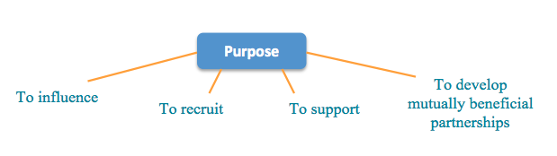
(a) Religious organizations
The dominating factor affecting post-secondary plans is religious belief in Qatar. Therefore, it is very important to communicate with people from religious organizations and ensure their support.

(b) Minister of Education: Supreme Educational Council

(c) Professional associations:
- Qatar Society of Engineers
- Qatar Businessmen Association

(d) Financial institution: Banks
We plan to provide students with banking services.

6.3 Channels

Based on a product market analysis, our top priority customers are remedial students, followed by professionals, housewives, high achieving students and entrepreneurs.

Our approach is customized to each specific target group. For remedial students and high achieving students, we will visit high schools annually and organize engaging special events and programs. For professionals, we will provide attractive promotional trainings. Similarly, housewives will be engaged through special workshops related to their interests such as integrating the workforce as a parent. Finally, we will engage current and prospective entrepreneurs directly through the organization of lectures and seminars geared to this market.
Stakeholders
Students
Parents
Administrators
Government
AUT-Q
Government
Remedial students
Professors

Industry connections, Innovation values, Input important
Professors
2
Private sector

6.4 Sales Strategies

(a) Preparation

Our six-month preparation period involves the development of advertising and related outreach materials. The following illustrates a proposed timeline for key annual promotional events.

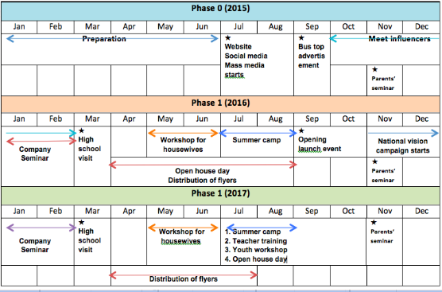

(b) Deployment
Meetings with key influencers
Ongoing relationship-building with religious leaders, government and industry partners.

Parent outreach and engagement
We will invite successful business people to address the parents about the economic trends or national development and specific needs of the labor market.

Promotional trainings for companies (January and February annually)
Leadership and management (annual topics chosen to promote AUT-Q programming)

- High school visits (February annually)
- Give and opportunity for students and teachers to learn more about our university
- Student seminar
Since many students report difficulties identifying a career, we will invite successful young people to act as mentors and serve the purpose of inspiring and providing guidance for future careers.

- Open house (First day of April through August initially, July – August in later years)
Tours promote and encourage familiarity with AUT-Q.

- Workshop for housewives (May and June, annually)
Topic includes early childhood education and technology.

- Summer camp (July – August, annually)
Summer camps designed for students from primary and secondary school will create an opportunity for younger students to begin at an early age to think about entering our university.

- Green project (July – August, annually)
In tune with QNV 2030 and contemporary trends, the university will also create a green project promoting solar technology, effective use of water resources projects as our two main green initiatives.

- Education awareness campaign (October, annually)
The campaign responds to the identified need to motivate Qataris to enter post-secondary education with an eye to enter the Qatari economy.

- High school teacher training (July-August, annually)
The training is aimed to provide new teaching resources and curriculum for teachers and includes topics such as ‘Emerging technologies for educational change’

- Youth camp (July-August, annually)
Themes will be different annually according to the phases

6.5 Pricing

Tuition Fees Per Credit Hour
 | Course/Program | Tuition fees per credit hour (USD)
Phase 1 | Business | 350
Phase 1 | Alternative energy engineering | 400
Phase 1 | Entrepreneurship | 350
Phase 1 | Maritime engineering | 400
Phase 1 | Renewable Energy | 400
Phase 1 | Remedial course | 300
Phase 2 | Nursing & Health Sciences | 350
Phase 2 | Liberal Arts Academy | 300
Phase 2 | Applied Technology in Education | 330
Phase 2 | Environmental innovation | 330
Phase 2 | Access technology courses | 330
Phase 2 | Conversational English course | 280
Phase 3 | Applied Sciences Academy | 350
Phase 3 | Fine Arts Institute | 400
Phase 3 | Tourism: Liberal Arts Academy | 300
Phase 3 | Masters in Laws | 300

6.6 Business case, ROI

Stakeholders | Benefits
Students | Fieldwork/industry connection, Professional development, Academic-  experiential learning
Parents | “Western” education in cultural environment
Professors | Industry connections, Innovation values, Input important
Administrators | Input integrated, Connections to government and industry
Government | Animated national vision: Qatarization support, Attends to educational & sustainability aims, Qatari-centered
Private sector | Market-ready students, Highly specialized workers, Qualified employees

7. SWOT Analysis

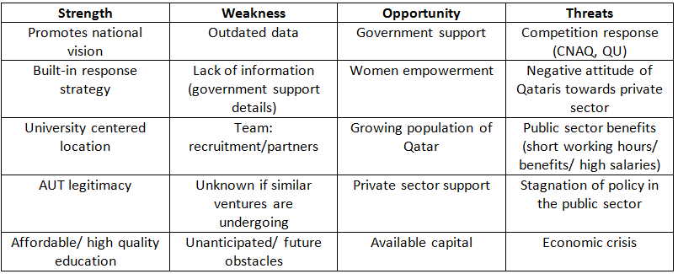

8. Operations

8.1 Location
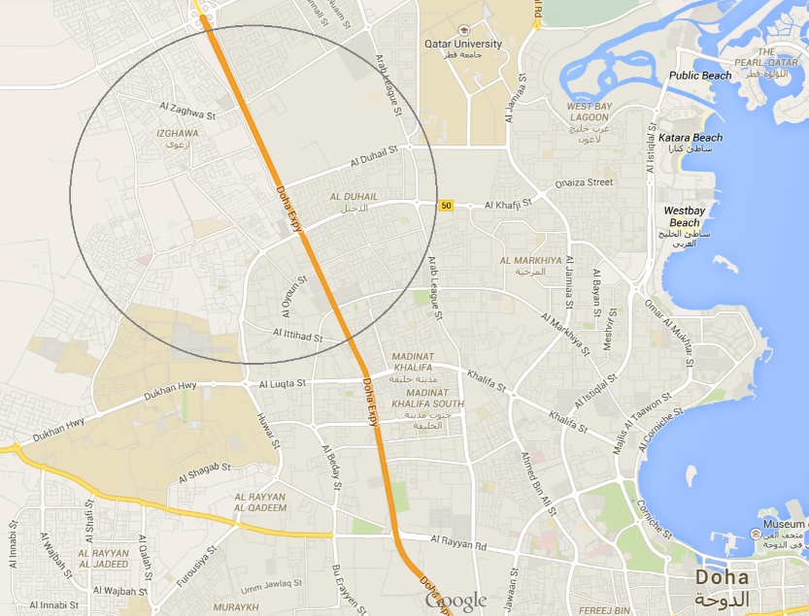
AUT-Q will have its campus in the City of Doha, in close proximity to the Education. The choice of location is motivated by two factors. First, real estate prices on the outskirts of the busy commercial capital are much lower and more space is available for establishing a viable campus. Second, operating in the proximity to the Education City allows for a productive interaction between AUT-Q’s faculties and student bodies and the institutions of the Education City.

The ideal spot is the area north-east of the Education City and south-west of Qatar University. The short commute between campuses means AUT-Q functions as a geographic and a symbolic meeting place between the two main approaches to higher education: the cutting-edge Western approach of the Education City and the traditional Islamic values-based approach of Qatar University.

8.2 Facilities

During the start-up stage AUT-Q campus facilities will be leased. It is expected that the Qatari government will cover some of the costs associated with leasing and operating the facilities. The precise share of government participation as well as its form is subject to future negotiations.

8.3 Organizational Structure

AUT-Q expects to maintain a full complement of support services to ensure the University’s academic operation in Qatar runs smoothly. The campus community is modelled after the administrative model of AUT to provide the services and support necessary for accomplishing the University’s teaching, research, and service missions. The organizational structure of AUT-Q is represented in the following chart:
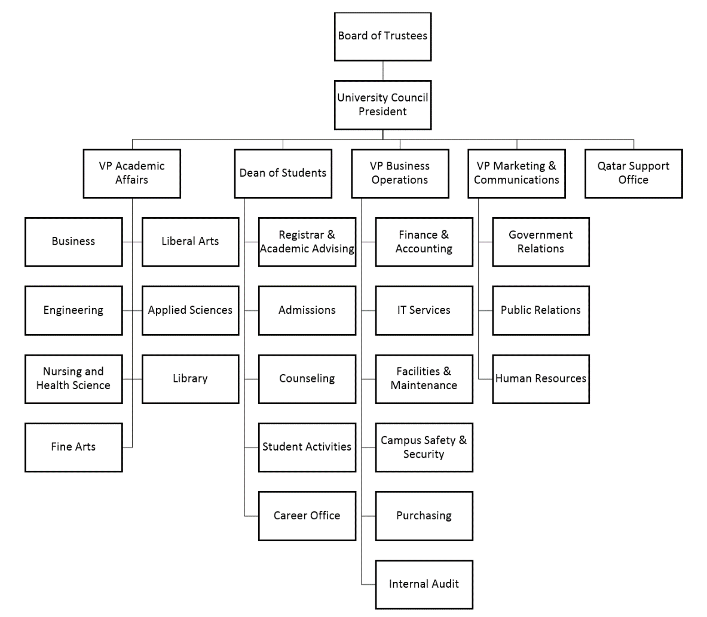

8.4 Key Operational Offices

(a) Business Operations
The goal of the Business Operations office is to support the University’s ability to meet its objectives on a day-to-day basis as well as in the long run. Among other things, the office provides accounting services and financial information to internal and external users. It ensures that adequate accounting controls are in place and are operating as designed.

The department of Information Technology operates under the umbrella of Business Operations, to provide technology services to faculty, staff, students, and affiliates. It offers creative technology service that animates the education experience at AUT-Q, as framed through the perspective of end users, not technology professionals. It responds with flexibility and creativity to the challenges of a rapidly changing IT environment.

(b) Office of Marketing and Communications
The Office of Marketing and Communications at AUT-Q promotes the campus by communicating to the community in Qatar, the region and the world about its mission, goals and achievements through targeted communication, marketing and public relations strategies. The Office promotes the campus image both within the University itself and to various external audiences. The office supports student, faculty and staff recruitment efforts. It promotes community service and outreach programs. It also assists in fostering collaboration and partnerships with governmental bodies (e.g. the Supreme Education Council, Ministry of Education, the Qatar Foundation for Education, Science and Community Development), Education City institutions, the Qatar University, and other educational institutions in the country. Its focus is on forging lasting relationships that bring both intellectual and financial resources to AUT-Q.

(c) Qatar Support Office
The Qatar Support Office serves as the liaison between the AUT and AUT-Q, conducting communication between the two campuses and their respective students, faculty and staff. It capitalizes on the intellectual and administrative resources of AUT and its know-how to make sure that AUT-Q meets its objectives.

8.5 Personnel Plan

To build its brand as an institution that provides high quality education, AUT-Q hires only full-time, tenure-track faculty members. AUT-Q seeks to fill its faculty positions with the brightest and most qualified candidates the market has to offer. However, in line with the host country’s policy of “Qatarization”, Qatari nationals are given priority over equally qualified foreign residents.

During the start-up stage (5 years), AUT-Q expects to maintain a student-to-faculty ratio of 25:1. This relatively high ratio is a cost-saving measure. Once the University is established and there is a better understanding of the enrolment potential of its programs, AUT-Q will gradually reduce the ratio to about 20:1. To provide a point of reference, the current student-to-faculty ratio at the University of McGill is 16:1. Note that this ratio includes temps, adjuncts, lecturers, part-timers, and non-tenure tracks. These options are incongruent with the image of AUT-Q which considers economic well-being and career satisfaction of its teaching staff a top priority.

Administrative staff are hired on the basis of 1 administrative staff member per 4 faculty members. IT, library, maintenance, and other staff will be hired as needed, either on a full-time or part-time basis.

For more detailed information on wages of faculty and administrative staff, as well as budget allocated to AUT-Q’s various offices, see Appendix 1: Pro Forma Financial Statements.

9. Finance

9.1 Financial Strategy

(a) Big Picture

AUT-Q’s financial strategy is based on two core principles: (1) establishing and fostering partnerships with government agencies of Qatar, (2) diversification of revenue streams. Implementation of these two principles will ensure AUT-Q’s short- and long-term financial sustainability.
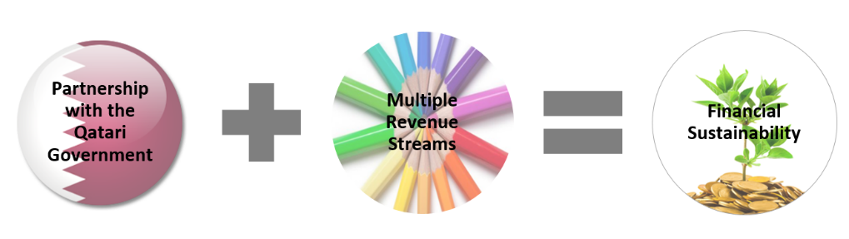

(b) Partnership with the Qatari Government

Establishing and maintaining partnerships with government agencies of Qatar is the cornerstone of AUT-Q’s success as a viable educational institution. A non-profit institution, such as a university, is a very capital-intensive undertaking. As such, it requires significant inflows of cash normally acquired through donations, government funding, research grants, and other means. The main attraction of Qatar in this regard is the fact that its government is willing to subsidize foreign post-secondary educational institutions that establish their branches in Qatar. In the past two decades, foreign colleges and universities have been flocking to Qatar in order to benefit from the government’s generous support. The following numbers are a case in point.

Institution | Level of Government Support
Georgetown University | $45 million per year + undisclosed amount
Texas A&M University | All expenses for 10 years + undisclosed amount
Weill Cornell Medical College | $750 million + undisclosed amount
Virginia Commonwealth University | $50 million per year + undisclosed amount
College of the North Atlantic | $326 million

Because tuition alone is not sufficient to cover all the costs associated with running a viable university, it is of paramount importance for AUT to come to an agreement with the government of Qatar with regard to the amount of government support. An initiative is currently underway to reach this agreement before AUT-Q campus is established.

(c) Diversification of Revenue Streams

Once government support is secured and the campus is established, AUT-Q will diversify its revenue streams in order to mitigate potential, if unlikely, risks associated with low enrolments and reduced level of government support due to unforeseen market fluctuations or change in government policies. AUT-Q’s long term financial vision includes partnerships with business ventures, the use of surplus to create an endowment fund, fundraising, creation of distance learning and continuing education programs.

9.2 Funding Requirements

(a) Assumptions

For the purposes of our financial forecast we assume that the Qatari government will cover fifty (50) per cent of AUT-Q’s start-up and operating costs. This assumption is realistic and quite conservative, given the government’s level of support of foreign schools that have already established their branches in Qatar.

(b) Start-up and Operational Costs Covered by the Donor

Year | Amount
0 | $3,310,000
1 | $1,818,750
2 | $297,250

(c) Sources of Funding

Funding will be provided by a donor, who is currently involved in a business venture in Qatar. The amounts set out above can be either structured as a charitable donation of the operating grant or a long term, low interest loan, payable in instalments and only on condition that AUT-Q generates surplus.

In Year 0, the donor splits the costs with the Qatari government in equal shares. In Years 1 and 2, the costs are split three way, with the larger amounts being covered by the Qatari government and AUT-Q’s tuition revenue. In Year 3 and following, AUT-Q is expected to generate enough revenue in tuition to be able to split the costs with the Qatari government without the help of the donor. For more detail, see Appendix 1: Pro Forma Financial Statements (1. Revenue & Expense Summary).

9.3 Financial Forecast

(a) Assumptions

Our forecast is based on two assumptions:
- The Qatari government will cover fifty (50) per cent of AUT-Q’s start-up and operating costs.
- AUT-Q will meet its enrolment projections.

AUT-Q’s enrolment projections are summarized in the following chart:

Total Enrolments
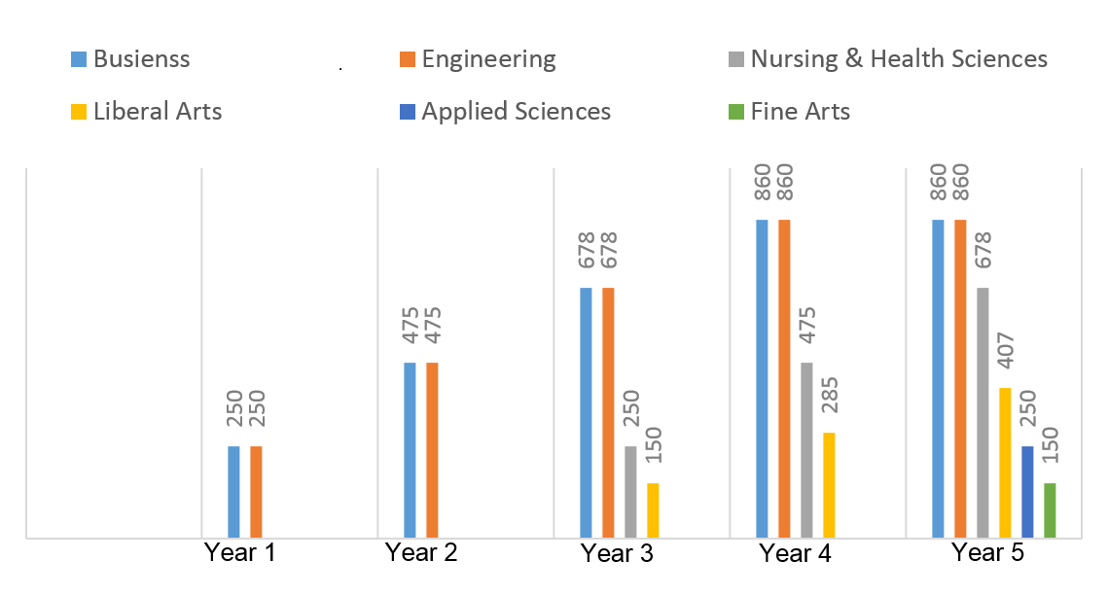
In calculating the enrolments, we further assume that there will be a ten (10) percent rate of attrition as students progress through each year of academic studies.

(b) Revenues and Expenses

Based on our assumptions, our total revenues and expenses in the six year period following the launch are projected to be as follows:

Revenues and Expenses
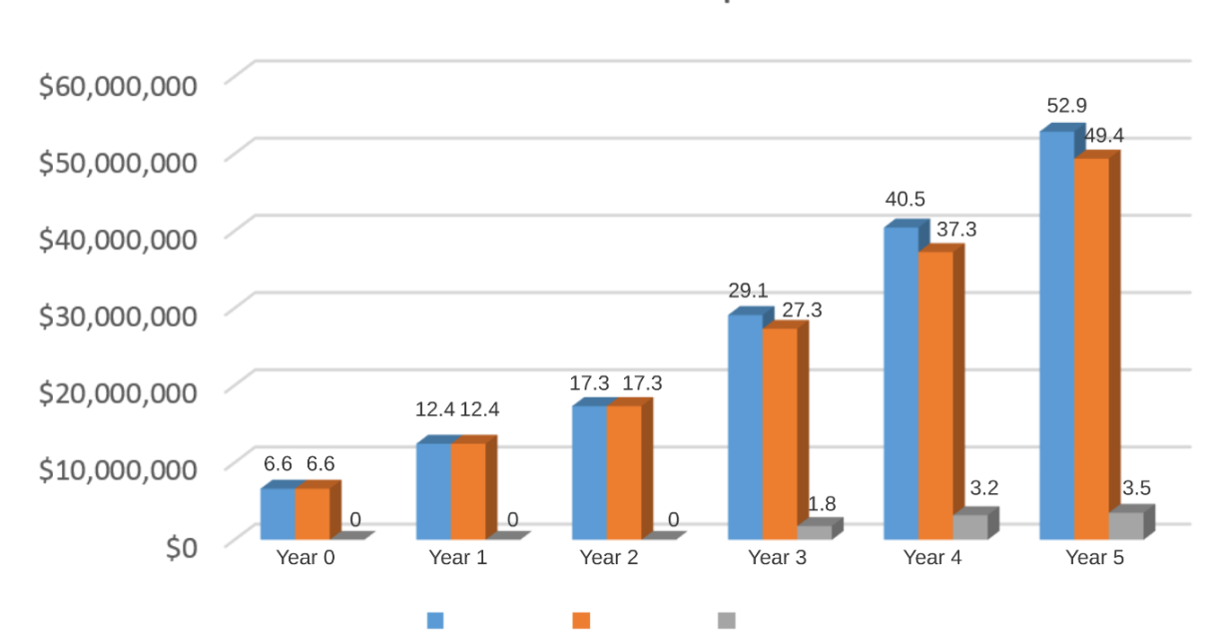
Revenues Expenses Surplus

(c) Surplus

Maintaining a balanced budget is essential to AUT-Q’s success. As shown in the chart above, starting from Year 3, AUT-Q is expected to generate a modest surplus. The surplus is the money that AUT-Q can use to create an endowment fund that will be invested in financial markets to generate investment income. A steady growth of our surplus will also allow AUT-Q to allocate additional funds to hire new employees, open new programs, and invest in marketing campaigns. Also, if the operating grant from the donor is structured as long term low interest loan, the surplus will be used to repay the loan.

(d) Cash Flow

The fact that AUT-Q will maintain a balanced budget, and even generate a surplus, does not necessarily mean that that it will be sufficiently liquid on a month-to-month basis. As AUT-Q relies heavily on tuition as one of its main sources of revenue, it is particularly susceptible to the risk of having a negative cash balance. The following chart illustrates the matter:

Cash Flow (Year 1)
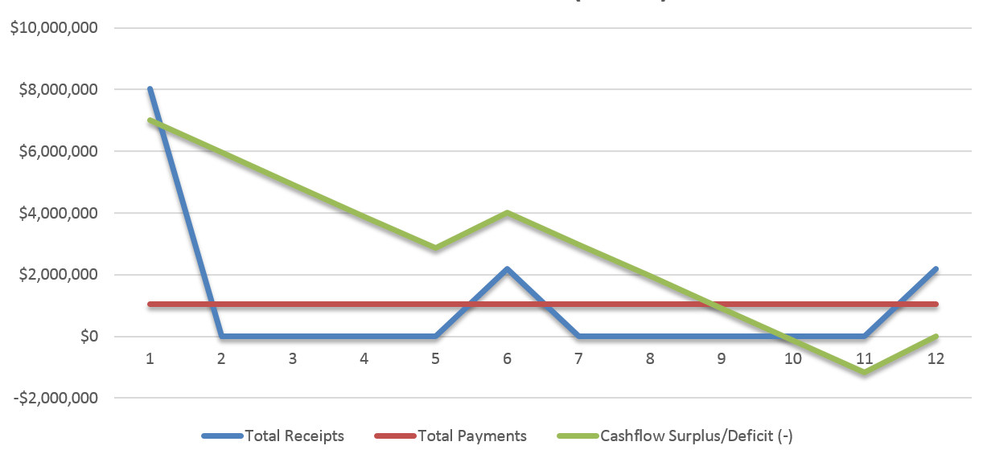

Assuming that students do not pay their tuition the moment they receive their bill, it is quite possible that AUT-Q will end up collecting the bulk of tuition payments near the end of each semester. As the year end approaches, AUT-Q is likely to incur a negative cash balance because the grant funds and the revenues from the first semester tuition payments will be depleted before the second batch of tuition payments comes through. Should this happen, the University would not be able to pay bills and wages. Proactive short-term financing must be arranged to prevent this from happening. As the University begins to generate surplus, a certain share of that amount can be used for the purpose year-end financing. Doing so will help reduce costs associated with interest payments on a loan from a third party. For more detail, see Appendix 2: Cash Flow Statement for Year 1.

(e) Break Even

The revenue and expense summary found in Appendix 1 shows that, due to the government support and the donor’s grant, the University is expected to run a break even budget throughout the entire start-up period. Starting with Year 3, the University will generate a surplus.

In the event that the operational grant is structured as a long-term loan rather than a gift, the break even analysis must focus on the net present value (NPV) of investment, taking into account the costs of capital employed. In our case the investment amount consists of $3,310,000 of initial investment and $1,818,950 and $297,250 of subsequent investment advanced in Years 1 and 2. NPV break-even analysis allows to determine the net value of future cash flows in today’s dollars.

To find out if the donor’s investment in AUT-Q over the course of five years is economically feasible, we have to determine the NPV of future cash flows arising from the company in Years 1-5. In Appendix 1 these cash flows are represented by Annual Surplus. To calculate the NPV of these cash flows we will assume a discount rate of 12%. The rate of 12% represents what the donor expects his annual rate of return to be if he invested the capital in a stock portfolio on TSX instead of AUT-Q. As shown in Appendix 3: Break Even Economic Feasibility Analysis, at the discount rate of 12% the donor will recoup his investment in Year 5 or, in other words, he will break even on a net present value. The NPV of all future cash flows in six years minus the NPV of the start-up and operating costs covered by the donor’s grant results in the overall NPV of $105,013. Needless to say, it is significantly less than the NPV of potential cash flows that would be generated by investing on TSX. Our NPV break even analysis highlights the important point that the motivations of the donor of the operational grant, whether he expects to recoup his investment or not, must be, by and large, charitable.

9.4 Exit Strategy

The scenario where the donor must contemplate exit strategies arise only in the event that the operational grant is structured as a loan which is to be repaid from surplus. Provided AUT-Q meets its financial objectives, the donor/creditor will recoup the principal in Year 5 and accrued interest in Year 6.

http://gulfnews.com/life-style/education/co-education-vs-segregation-1.53464
Post-Secondary Education in Qatar Employer Demand, Student Choice, and Options for Policy, Report published by Rand-Qatar Policy Institute (http://www.rand.org/pubs/monographs/MG644.html).

